**LESSON 5: TRANSISTORS**

SOLID STATE DEVICE

* Is an electronic component that relies on the movement of electrons through solid materials, such as semiconductors, rather than relying on vacuum or moving parts. Examples include **transistors**, **diodes**, and **integrated circuits (ICs)**. These devices are compact, durable, energy-efficient, and form the backbone of modern electronics like smartphones, computers, and televisions.

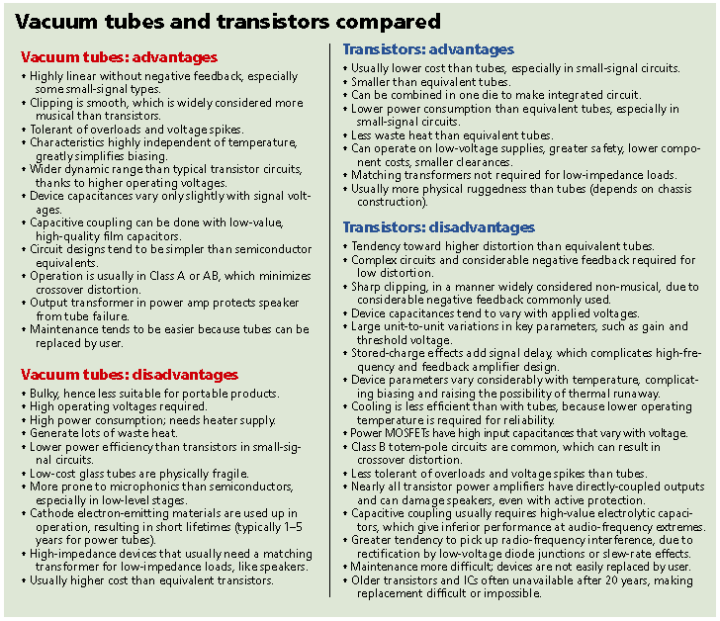

IN SHORT

VACUUM TUBES ARE: TRANSISTORS ARE:

* BIG - VERY SMALL
* HOT - NOT LIGHT BULD HEATED
* SLOW - FAST
* BROKE DOWN OFTEN - RELIABLE

TYPES OF TANSISTORS

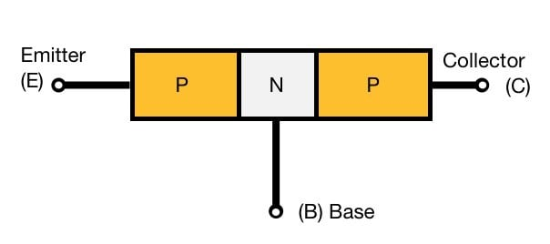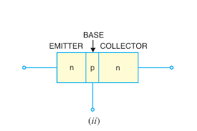

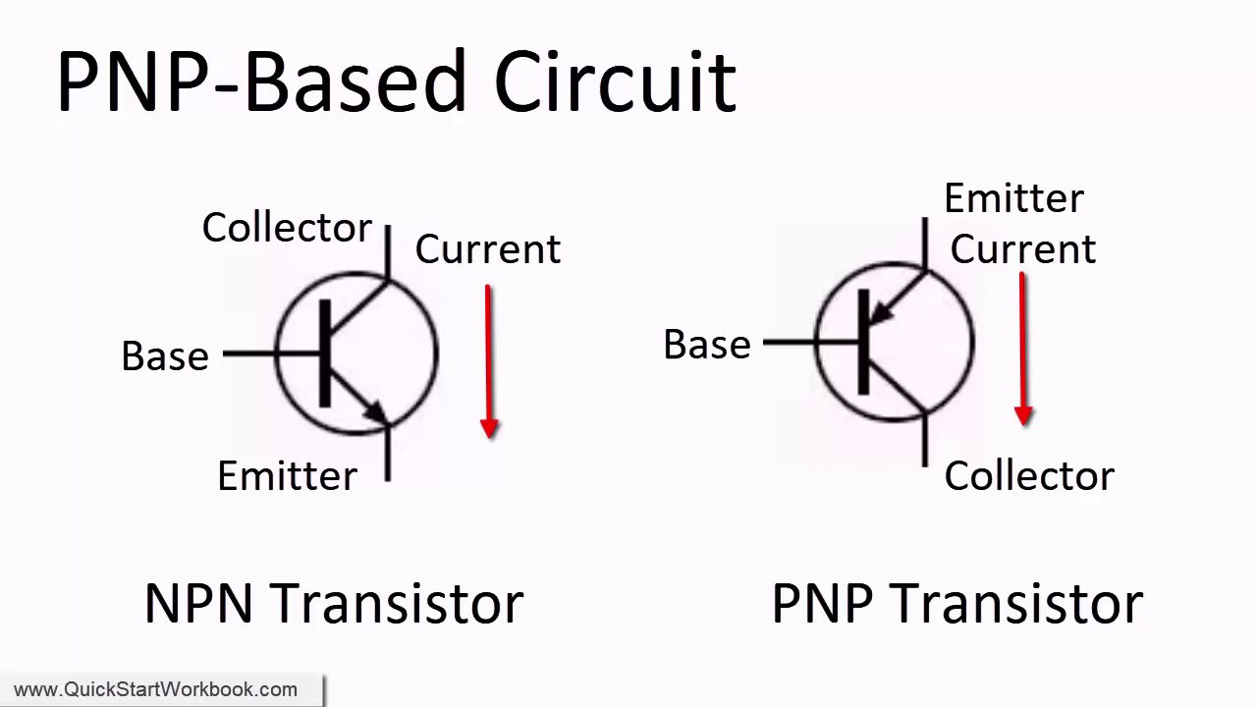

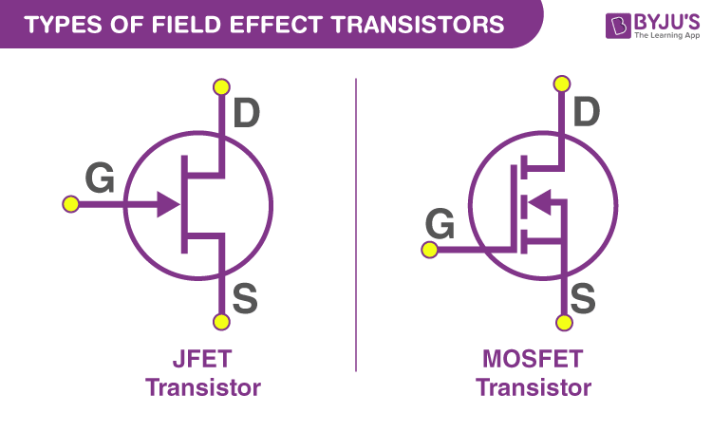

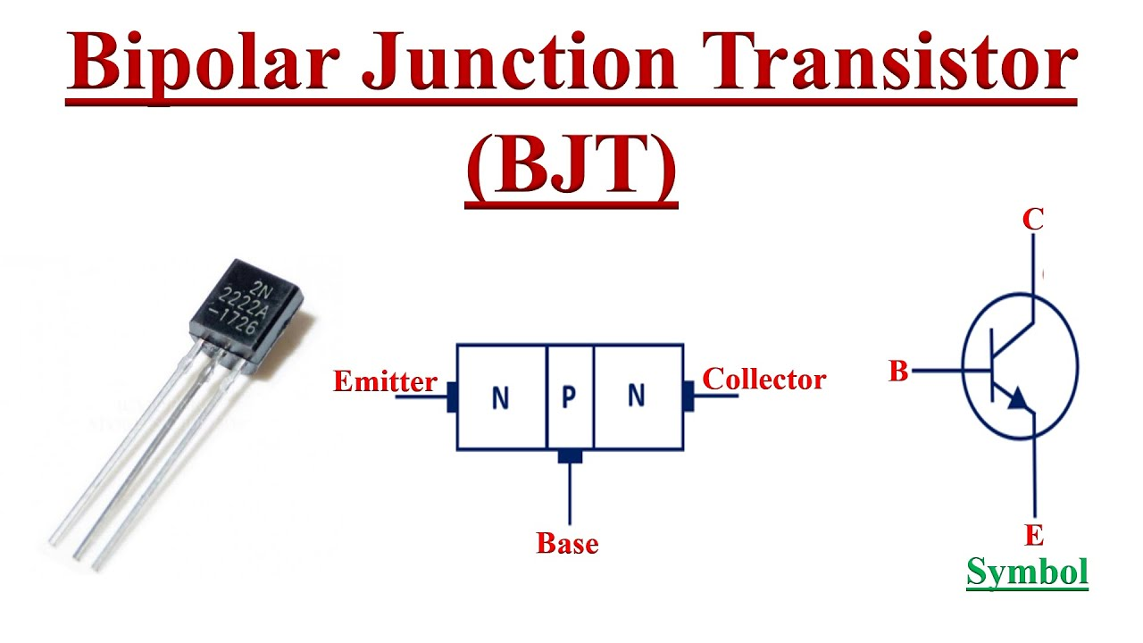

FLOW OF CURRENT

NPN AND PNP TRANSISTOR

